UNITED STATES

SECURITIES AND EXCHANGE COMMISSION

Washington, D.C. 20549

_____________________

FORM 8-K

_____________________

CURRENT REPORT

PURSUANT TO SECTION 13 OR 15(d)

OF THE SECURITIES EXCHANGE ACT OF 1934

Date of Report (Date of Earliest Event Reported): September 21, 2022

_____________________

COEPTIS THERAPEUTICS, INC.

(Exact name of registrant as specified in its charter)

Delaware | 000-56194 |  |  | 84-3998117
(State or other jurisdiction |  | (Commission |  | (I.R.S. Employer
of incorporation) | File Number) |  |  | Identification No.)
105 Bradford Rd, Suite 420
Wexford, Pennsylvania |  |  |  | 15090
(Address of principal executive offices) |  |  |  | (Zip Code)
 | 724-934-6467
 | (Registrant’s telephone number, including area code)

____________________________________________________________

(Former name or former address, if changed since last report)

Check the appropriate box below if the Form 8-K filing is intended to simultaneously satisfy the filing obligation of the registrant under any of the following provisions:

  - Written communications pursuant to Rule 425 under the Securities Act (17 CFR 230.425) x Soliciting material pursuant to Rule 14a-12 under the Exchange Act (17 CFR 240.14a-12)

- Pre-commencement communications pursuant to Rule 14d-2(b) under the Exchange Act (17 CFR 240.14d-2(b))

- Pre-commencement communications pursuant to Rule 13e-4(c) under the Exchange Act (17 CFR 240.13e-4(c)) Securities registered pursuant to Section 12(b) of the Act:
Title of each class | Trading Symbol(s) | Name of each exchange on which registered
N/A | N/A | N/A

Indicate by check mark whether the registrant is an emerging growth company as defined in Rule 405 of the Securities Act of 1933 (§230.405 of this chapter) or Rule 12b-2 of the Securities Exchange Act of 1934 (§240.12b-2 of this chapter).
Emerging growth company ☒

If an emerging growth company, indicate by check mark if the registrant has elected not to use the extended transition period for complying with any new or revised financial accounting standards provided pursuant to Section 13(a) of the Exchange Act. ☐

Item 7.01 Regulation FD Disclosure

On September 21, 2022, Coeptis Therapeutics, Inc. (the “Company” or “Coeptis”) posted an investor presentation (the “Presentation”) to its website and it is available in the Presentations section of the Company’s website at https://coeptistx.com/presentation. A copy of the Presentation is included as Exhibit 99.1 to this Current Report on Form 8-K.

The Company intends to use the Presentation in presentations to investors and analysts from time to time in the future, including in connection with the proposed business combination involving the Company and Bull Horn Holdings Corp (“Bull Horn”). The furnishing of the information in this Current Report on Form 8-K is not intended to, and does not, constitute a determination by the Company that the information in this Current Report on Form 8-K is material or complete, or that investors should consider this information before making an investment decision with respect to any security of the Company. The information in the materials is presented as of September 21, 2022, and the Company does not assume any obligation to update such information in the future.

The information in Item 7.01 of this Current Report on Form 8-K shall not be deemed to be “filed” for the purposes of Section 18 of the Securities and Exchange Act of 1934, as amended (the “Exchange Act”), or otherwise subject to the liabilities of such section, nor shall such information be deemed incorporated by reference in any filing under the Securities Act of 1933, as amended, or the Exchange Act, except as shall be expressly set forth by specific reference in such a filing.

Item 8.01 Other Events

On September 21, 2022, Coeptis issued a press release announcing its previously disclosed exclusive license agreement with the University of Pittsburgh related to certain intellectual property rights to the Universal self-labeling SynNotch and CARs for programable antigen-targeting technology platform. The previous disclosure can be found in the Company’s Current Report on Form 8-K that was filed on September 7, 2022. A copy of the press release is included as Exhibit 99.2 to the Current Report on Form 8-K.

Item 9.01 |  | Financial Statements and Exhibits.
(d) Exhibits
Exhibit No. |  | Description
99.1 |  | Coeptis Therapeutics, Inc. Presentation
99.2 |  | Press Release, dated September 21, 2022

__________________________

2

Additional Information and Where to Find It

This communication may be deemed to be solicitation material in respect of the proposed business combination with Coeptis and Bull Horn. Coeptis has filed a preliminary proxy statement with the Securities and Exchange Commission (the “SEC”) and intends to file a definitive proxy statement and other relevant materials in connection with the proposed business combination. The definitive proxy statement will be sent or given to the stockholders of Coeptis. This communication is not a substitute for the definitive proxy statement or any other document that may be filed by Coeptis with the SEC.

SECURITY HOLDERS ARE ADVISED TO READ THE PROXY STATEMENT WHEN IT BECOMES AVAILABLE, BECAUSE IT WILL CONTAIN IMPORTANT INFORMATION ABOUT THE BUSINESS COMBINATION. The proxy statement and other relevant materials (when they become available), and any other documents filed by Coeptis with the SEC, may be obtained free of charge at the SEC’s website, at www.sec.gov.

Participants in the Solicitation

Coeptis and its directors, executive officers, other members of management and employees may be deemed participants in the solicitation of proxies from Coeptis’ stockholders with respect to the proposed business combination. Investors and securityholders may obtain more detailed information regarding the names and interests in the business combination of the directors and officers of Coeptis in Coeptis’ filings with the SEC. Additional information regarding the interests of such potential participants will also be included in the preliminary proxy statement and definitive proxy statement when they are filed with the SEC.

No Offer or Solicitation

This Current Report on Form 8-K and the exhibits hereto do not constitute a solicitation of a proxy, consent or authorization with respect to any securities or in respect of the proposed business combination. This Current Report on Form 8-K shall also not constitute an offer to sell or the solicitation of an offer to buy any securities, nor shall there be any sale of securities in any states or jurisdictions in which such offer, solicitation or sale would be unlawful prior to registration or qualification under the securities laws of any such jurisdiction. No offering of securities shall be made except by means of a prospectus meeting the requirements of Section 10 of the Securities Act of 1933, as amended, or an exemption therefrom.

Cautionary Note Regarding Forward-Looking Statements

Certain statements made herein and in the attached Presentation contain, and certain oral statements made by representatives of Coeptis and its respective affiliates, from time to time may contain, “forward-looking statements” within the meaning of the “safe harbor” provisions of the Private Securities Litigation Reform Act of 1995. Bull Horn’s and Coeptis’ actual results may differ from their expectations, estimates and projections and consequently, you should not rely on these forward-looking statements as predictions of future events. Words such as “expect,” “estimate,” “project,” “budget,” “forecast,” “anticipate,” “intend,” “plan,” “may,” “will,” “could,” “should,” “believes,” “predicts,” “potential,” “might” and “continues,” and similar expressions are intended to identify such forward-looking statements. These forward-looking statements include, without limitation, statements regarding (i) the technologies which are the subject of Coeptis’ potential expansion focus, including its option agreement with the University of Pittsburgh, (ii) Coeptis’ expectations with respect to future performance and anticipated financial impacts of the Bull Horn business combination, and (iii) the satisfaction of the closing conditions to such business combination and the timing of the completion of such business combination. These forward-looking statements involve significant risks and uncertainties that could cause actual results to differ materially from expected results. Most of these factors are outside of the control of Coeptis and are difficult to predict. Factors that may cause such differences include but are not limited to: (1) the occurrence of any event, change or other circumstances that could give rise to the termination of that certain Agreement and Plan of Merger dated effective as of April 18, 2022 (as may be further amended or supplemented from time to time, the “Merger Agreement”), with Coeptis, Bull Horn and BH Merger Sub Inc. (a wholly-owned subsidiary of Bull Horn); (2) the inability to complete the business combination, including due to the failure to obtain approval of the shareholders of Bull Horn or other conditions to closing in the Merger Agreement; (3) the inability to obtain or maintain the listing of Bull Horn’s securities on the Nasdaq Capital Market following the business combination; (4) the risk of significant redemptions by Bull Horn’s public stockholders in connection with the closing of the business combination, leaving the combined post-closing company with limited funds to finance its business plans; (5) the risk that the business combination disrupts current plans and operations of Coeptis as a result of the announcement and consummation of the business combination; (6) the ability to recognize the anticipated benefits of the business combination, which may be affected by, among other things, competition, the ability of the combined company to grow and manage growth economically and hire and retain key employees; (7) the risks that Coeptis’ products in development (including those which may be acquired from the University of Pittsburgh) fail clinical trials or are not approved by the U.S. Food and Drug Administration or other applicable regulatory authorities; (8) costs related to the business combination and expansion opportunities, including in connection with any exercise of Coeptis’ option with the University of Pittsburgh; (9) changes in applicable laws or regulations; (10) the possibility that Bull Horn or Coeptis may be adversely affected by other economic, business, and/or competitive factors; and (11) the impact of the global COVID-19 pandemic on any of the foregoing risks and other risks and uncertainties to be identified in the proxy statement (when available) relating to the business combination, including those under “Risk Factors” therein, and in other filings with the SEC made by Coeptis. The foregoing list of factors is not exclusive. Readers are referred to the most recent reports filed with the SEC by Coeptis. Readers are cautioned not to place undue reliance upon any forward-looking statements, which speak only as of the date made. Coeptis undertakes no obligation to update or revise the forward-looking statements, whether as a result of new information, future events or otherwise, subject to applicable law.

3

SIGNATURES

Pursuant to the requirements of the Securities Exchange Act of 1934, the registrant has duly caused this report to be signed on its behalf by the undersigned hereunto duly authorized.

 | Coeptis Therapeutics, Inc.
Date: September 21, 2022 | By: | /s/ David Mehalick
 |  | David Mehalick
 |  | Chief Executive Officer

4

Exhibit 99.1


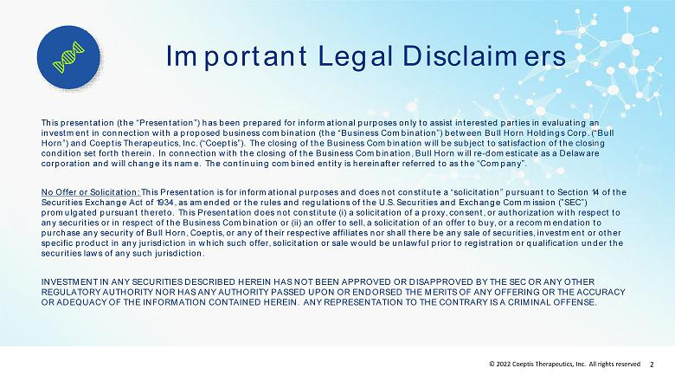

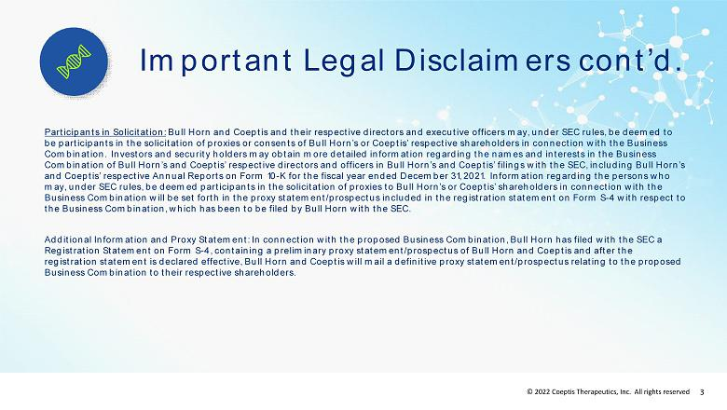

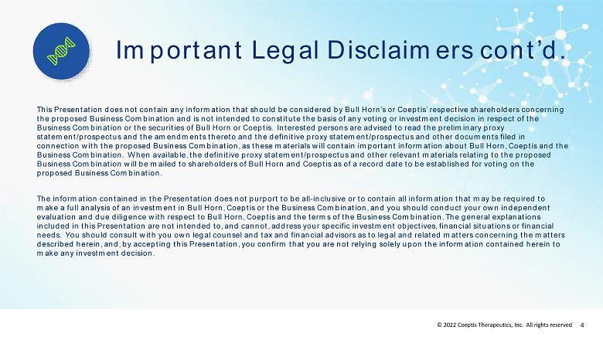

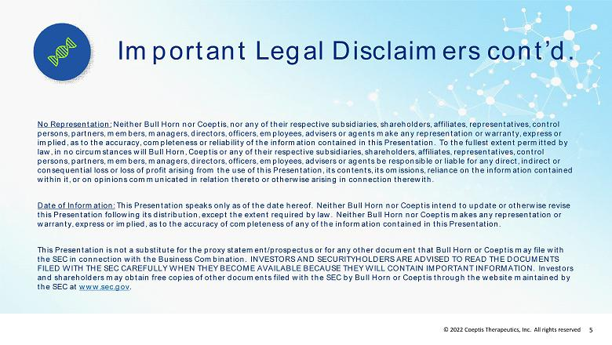

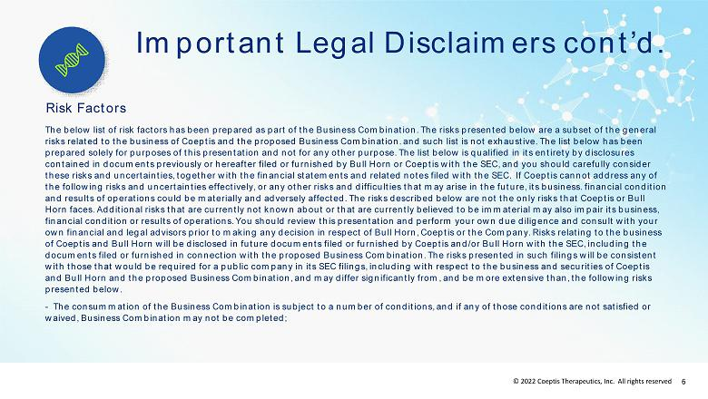

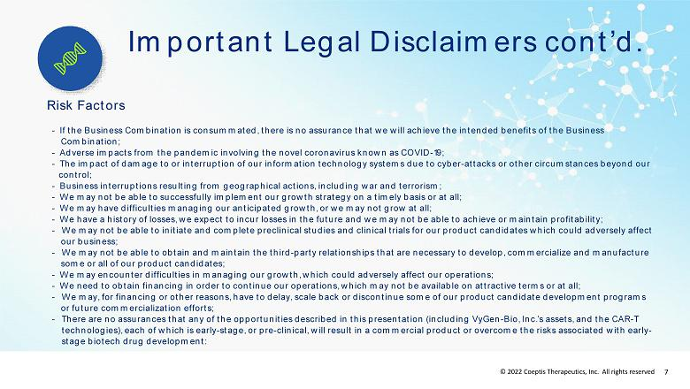

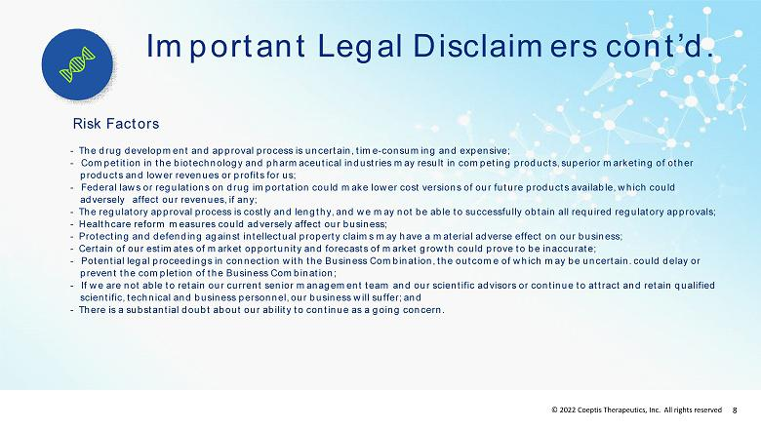

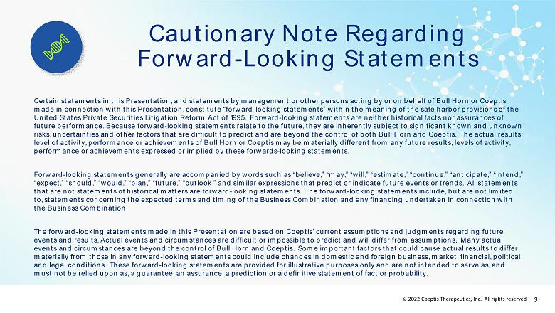



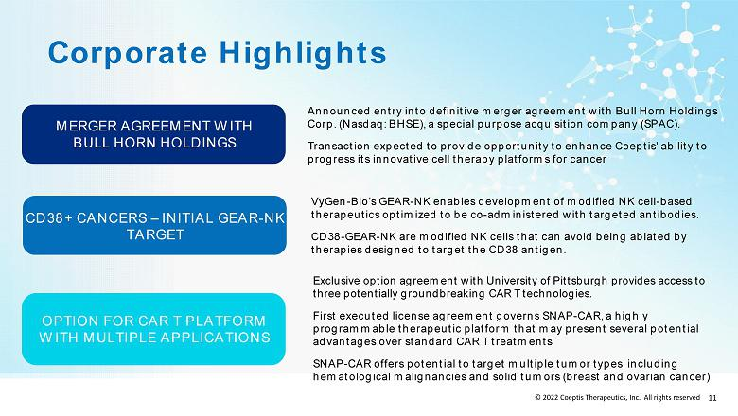

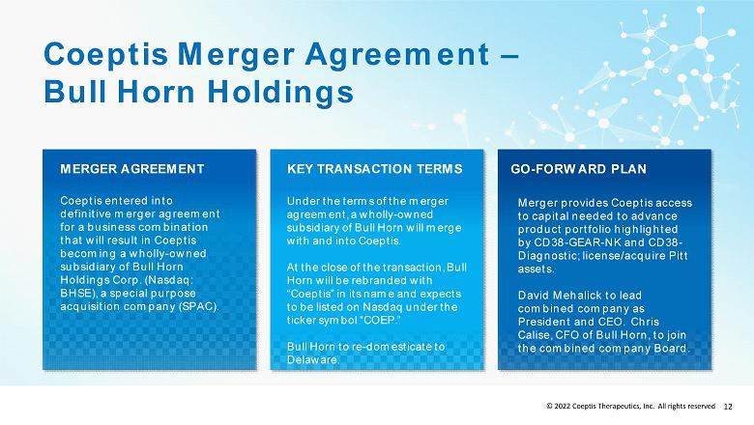

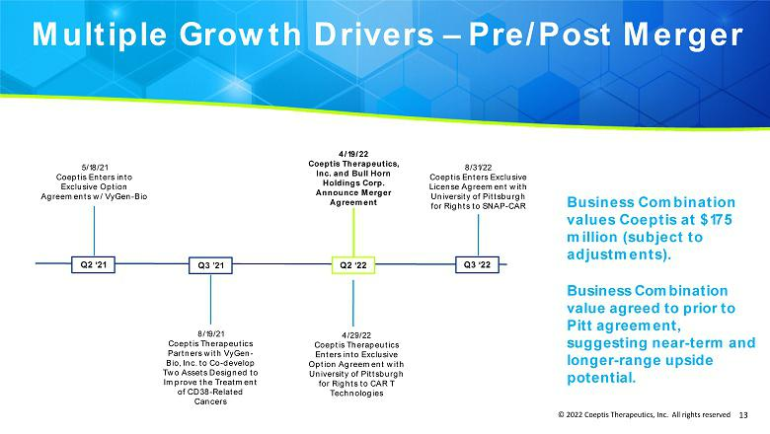

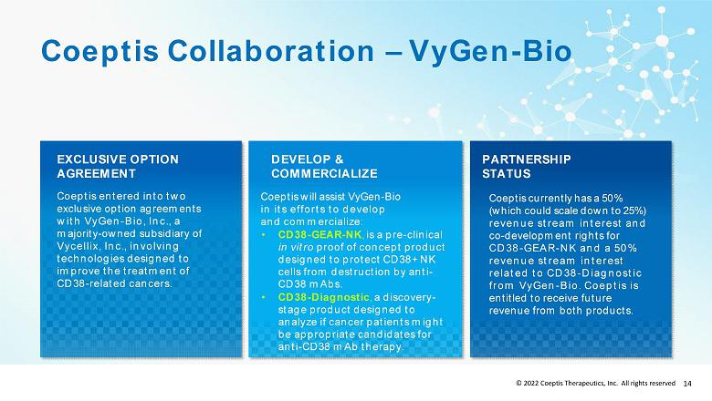

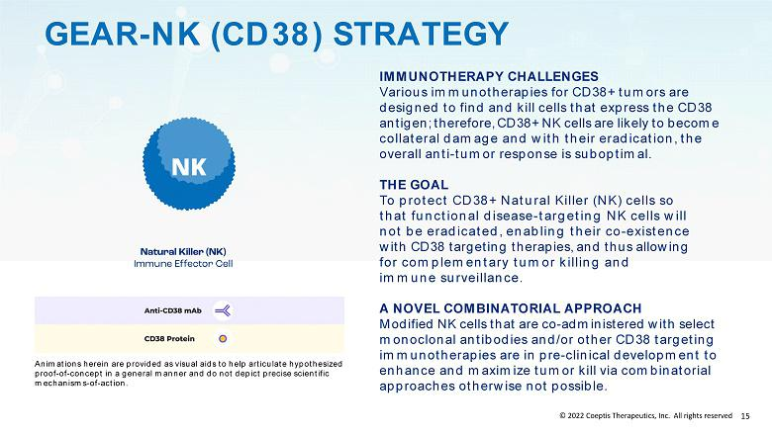

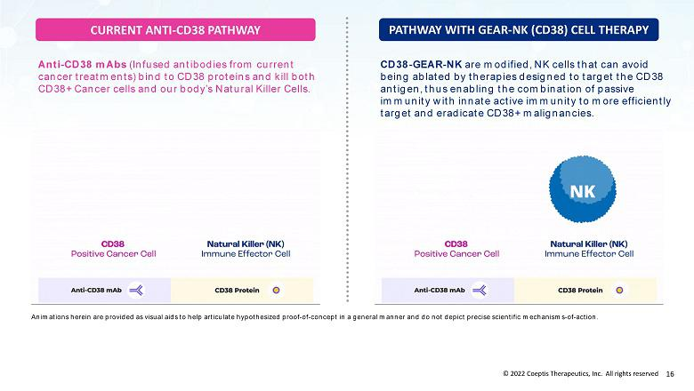

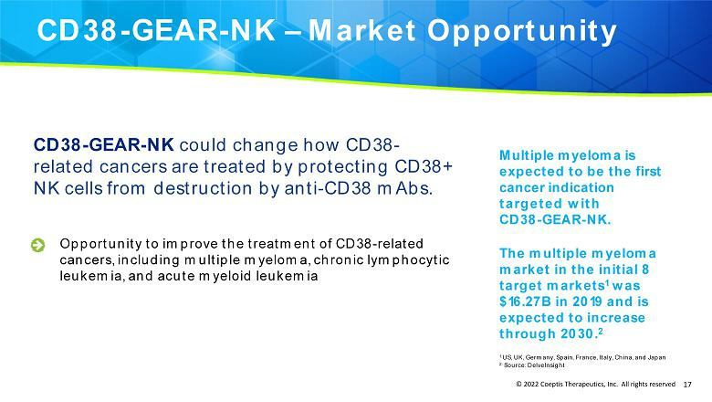

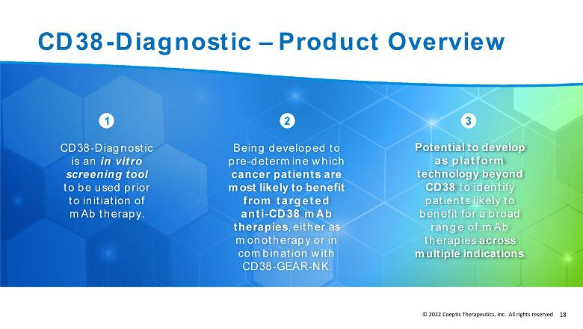

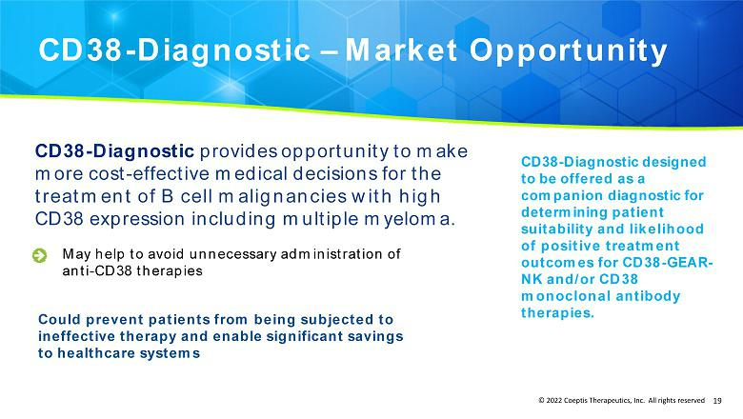

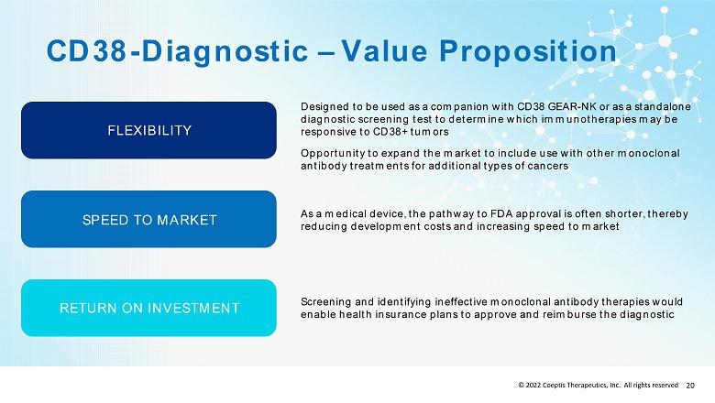

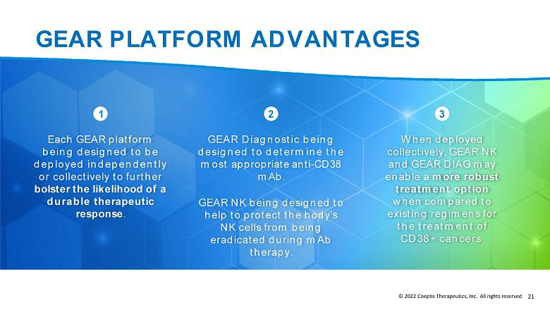

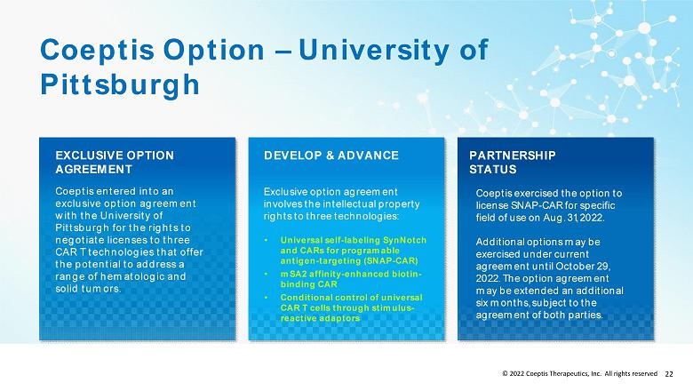

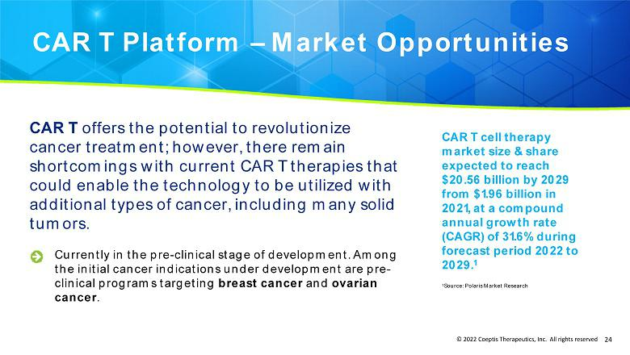

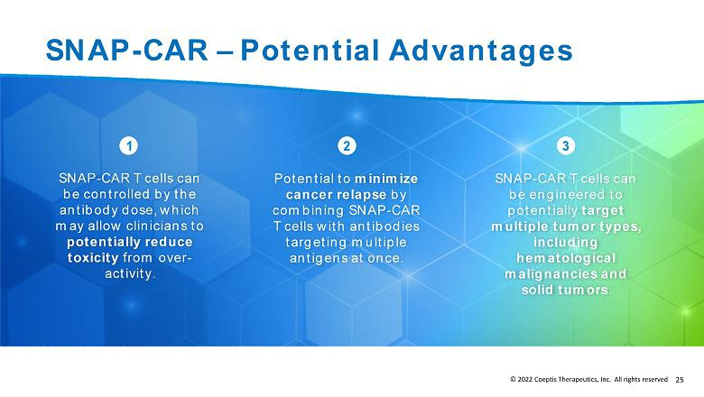

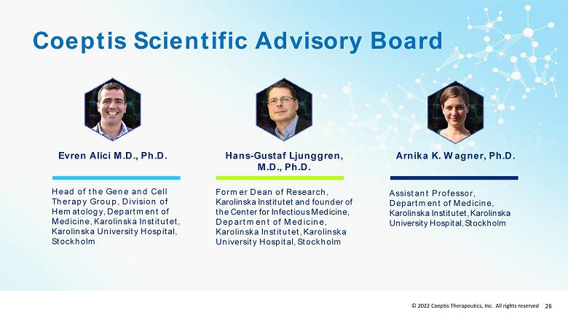

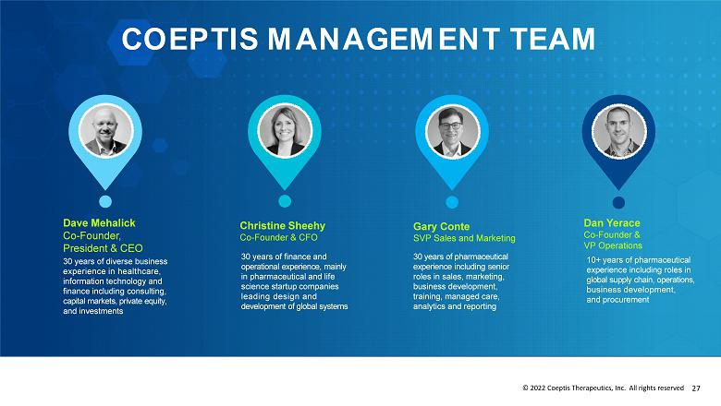

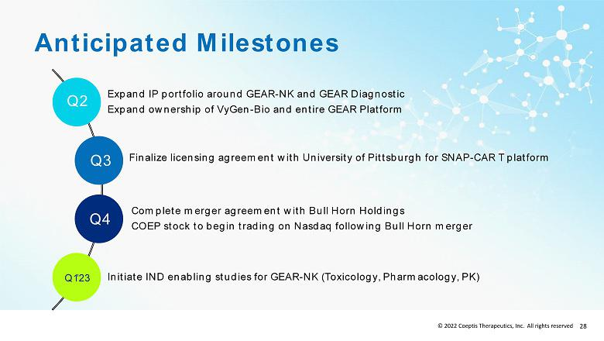

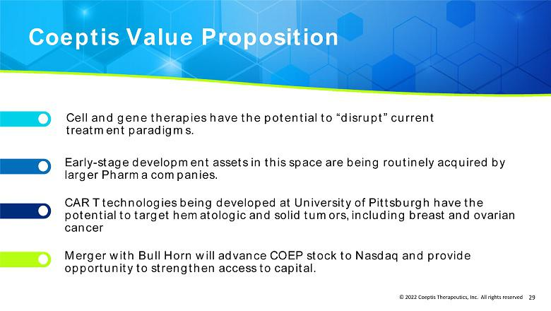

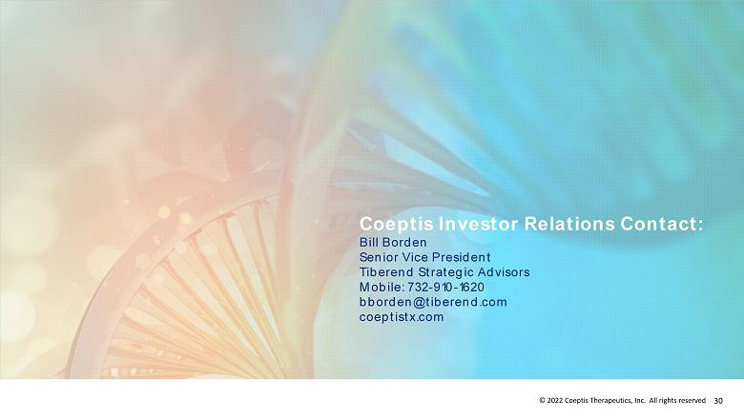

Exhibit 99.2

Coeptis Therapeutics Enters Exclusive License Agreement with University of Pittsburgh for Rights to SNAP-CAR, a “Multi-Antigen” CAR T Technology

SNAP-CAR therapy provides a highly programmable therapeutic platform designed to potentially target many tumor types, including hematological malignancies and solid tumors

Wexford, PA, September 21, 2022 – Coeptis Therapeutics, Inc. (OTC PINK: COEP) (“Coeptis” or “the Company”), a biopharmaceutical company developing innovative cell therapy platforms for cancer, today announced entry into an exclusive license agreement with the University of Pittsburgh for the rights to a chimeric antigen receptor T cell (CAR T) technology – SNAP-CAR – designed to target multiple antigens simultaneously and potentially address a range of hematologic and solid tumors, including breast and ovarian cancer. Completion of the exclusive license agreement for SNAP-CAR follows Coeptis’ entry into an option agreement with the University of Pittsburgh announced in May 2022.

Current CAR T therapies are designed to target specific tumor antigens that correspond to a specific cancer indication. This approach has proven effective in certain cancer types but limits the applicability of those CAR T therapies. SNAP-CAR is designed to be a “universal” CAR T cell therapy platform that can be adapted to different cancer indications. Instead of directly binding to a target on the tumor cell, CAR T cells are co-administered with one or more antibody adaptors that bind to the tumor cells and are fitted with a chemical group that irreversibly connects them to the SNAP-CAR on the therapeutic cells via a covalent bond. Pre-clinical studies in mice have demonstrated that by targeting tumors via antibody adaptor molecules, the SNAP-CAR therapy provides a highly programmable therapeutic platform.

“SNAP-CAR T cells can be engineered to address numerous cancers, including solid tumors, while providing researchers with the ability to rapidly screen multiple antibody candidates without the need to generate individual receptors,” said Jason Lohmueller, Ph.D., Assistant Professor of Surgery and Immunology in the Division of Surgical Oncology Research at the University of Pittsburgh. “Additionally, SNAP-CAR may offer the potential to mitigate the toxicity of CAR T therapy by allowing clinicians to control the adaptor dose. Further, the ability to combine SNAP-CAR T cells with antibodies targeting multiple antigens offers the potential to reduce the likelihood of cancer relapse,” said Alex Deiters, Ph.D., Professor of Chemistry at the University of Pittsburgh.

“SNAP-CAR represents a potential breakthrough in CAR T approaches and a significant addition to Coeptis’ expanding cell therapy product portfolio,” said Dave Mehalick, President and CEO of Coeptis Therapeutics. “Research at the University of Pittsburgh suggests that SNAP-CAR offers an opportunity to direct the power of CAR T to an array of cancers that have, until now, been inaccessible via current cell therapy technologies by providing a highly programmable antigen targeting platform. It is believed that SNAP-CAR could enable the development of CAR T therapies for many hematologic cancers as well as several types of solid tumors, including breast and ovarian cancer.”

Mr. Mehalick concluded: “Our vision at Coeptis is to be at the forefront of developing the next-generation cell therapy technologies, and we believe the advancements at the University of Pittsburgh, as well as those at VyGen-Bio, are potentially groundbreaking.”

About Coeptis Therapeutics, Inc.

Coeptis Therapeutics, Inc., along with its wholly owned subsidiary Coeptis Pharmaceuticals, Inc. (together “Coeptis”), is a biopharmaceutical company developing innovative cell therapy platforms for cancer that have the potential to disrupt conventional treatment paradigms and improve patient outcomes. Coeptis' product portfolio and rights are highlighted by a universal, multi-antigen CAR T technology licensed from the University of Pittsburgh (SNAP-CAR) and a cell therapy technology (CD38-GEAR-NK) and an in vitro diagnostic (CD38-Diagnostic) targeting CD38-related cancers, which the company is developing with VyGen-Bio and leading medical researchers at the Karolinska Institutet. Coeptis' business model is designed around maximizing the value of its current product portfolio and rights through in-license agreements, out-license agreements and co-development relationships, as well as entering into strategic partnerships to expand its product rights and offerings, specifically those targeting cancer. Coeptis was founded in 2017 and is headquartered in Wexford, Pa. For more information on Coeptis visit https://coeptistx.com/.

1

About the University of Pittsburgh

A nonsectarian, coeducational, state-related, public research university founded in 1787, the University of Pittsburgh (Pitt) is a member of the prestigious by-invitation-only Association of American Universities and internationally renowned as a leading center of learning and research in the arts, sciences, humanities, professions and health sciences. Comprising a Pittsburgh campus, which is home to 16 undergraduate, graduate and professional schools, and four Western Pennsylvania regional campuses, Pitt offers nearly 500 distinct degree programs and confers more than 8,500 degrees annually. Pitt has ranked among the top 10 recipients of funding from the National Institutes of Health since 1998 and is ranked among the top 10 American research universities nationally in terms of total federal science and engineering research and development obligations. For more information, visit www.pitt.edu.

Cautionary Note Regarding Forward-Looking Statements

This press release and statements of our management made in connection therewith contain or may contain “forward-looking statements” (as defined in Section 27A of the Securities Act of 1933, as amended, and Section 21E of the Securities Exchange Act of 1934, as amended). Forward-looking statements include statements concerning our plans, objectives, goals, strategies, future events or performance, and underlying assumptions and other statements that are other than statements of historical facts. When we use words such as "may," "will," "intend," "should," "believe," "expect," "anticipate," "project," "estimate" or similar expressions that do not relate solely to historical matters, we are making forward-looking statements. Forward-looking statements are not guarantee of future performance and involve significant risks and uncertainties that may cause the actual results (including, without limitation (i) whether we will exercise the option with the University of Pittsburgh, or the benefits of the technology subject to such option and (ii) whether we will be able to close our proposed merger with Bull Horn Holdings Corp. (Nasdaq: BHSE), each as described herein) to differ materially and perhaps substantially from our expectations discussed in the forward-looking statements. All forward-looking statements are subject to significant uncertainties and risks including, but not limited, to those risks contained or to be contained in reports and other filings filed by us with the Securities and Exchange Commission. For these reasons, among others, investors are cautioned not to place undue reliance upon any forward-looking statements in this press release. Additional factors are discussed in our filings made or to be made with the U.S. Securities and Exchange Commission, which are available for review at www.sec.gov. We undertake no obligation to publicly revise these forward–looking statements to reflect events or circumstances that arise after the date hereof unless required by applicable laws, regulations or rules.

Participants in the Solicitation

Coeptis and its directors, executive officers, other members of management and employees may be deemed participants in the solicitation of proxies from Coeptis’ stockholders with respect to the proposed business combination with Bull Horn Holdings. Investors and securityholders may obtain more detailed information regarding the names and interests in the business combination of the directors and officers of Coeptis in Coeptis’ filings with the SEC. Additional information regarding the interests of such potential participants will also be included in the preliminary proxy statement and definitive proxy statement when they are filed with the SEC.

No Offer or Solicitation

This press release does not constitute a solicitation of a proxy, consent or authorization with respect to any securities or in respect of the proposed business combination with Bull Horn Holdings. This press release shall also not constitute an offer to sell or the solicitation of an offer to buy any securities, nor shall there be any sale of securities in any states or jurisdictions in which such offer, solicitation or sale would be unlawful prior to registration or qualification under the securities laws of any such jurisdiction. No offering of securities shall be made except by means of a prospectus meeting the requirements of Section 10 of the Securities Act of 1933, as amended, or an exemption therefrom.

CONTACTS

Coeptis Therapeutics, Inc.

Investors

Tiberend Strategic Advisors, Inc.

Jon Nugent

205-566-3026

jnugent@tiberend.com

Media

David Schemelia

609-468-9325

dschemelia@tiberend.com

Bull Horn Holdings Corp.

Edelman

bullhornmedia@edelman.com

University of Pittsburgh

Innovation Institute

412-383-7670

2

